**IoT based garbage collection and monitoring system**

In metropolitan cities, it is difficult to check every place where the garbage bin yard is full or not.

The overflow of the garbage bin leads to unhygienic environment and this leads to disease spread. So in order to make our environments clean and safe we have proposed a smart system that improves the already existing system.

Arduino Uno

LCD display

Power supply

Power supply

Ultrasonic sensor

Wi-Fi module

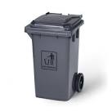

Connection between Website Libraries and Project

Web server

Fig Block diagram

**How the system works?**

The system monitors the garbage bins and informs about the level of garbage collected in the garbage bins via a web page.

* Website is developed
* Ultrasonic sensor is placed over the bin to detect the garbage level of the bin
* This sensor feeds data about the status of the garbage to the Arduino
* ESP8266 SoC is connected to the Arduino
* Connection between the website and the Wi-Fi module Arduino is made so as to transmit information to the website through Internet connection
* The LCD screen is used to display the status of the level of garbage collected in the bins
* Whereas a web page is built to show the status to the user monitoring it
* The system puts on the buzzer when the level of garbage collected crosses the set limit

Design of the garbage bin [flow diagram]

Sensor

Municipal car

Data on web server

Sensor data > threshold

Yes

No

Fig 2. Flow diagram

**Database design**

Municipal admin

Garbage-bin

Show

1

N

Fig 3. Database design layout

**ESP8266**

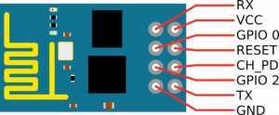

1. VCC – – > 3.3V
2. GND – – > GND
3. CH_PD – – > 3.3V
4. RST – – > Normally Open; GND to Reset
5. GPIO0 – – > GND
6. TX – – > TX of Arduino
7. 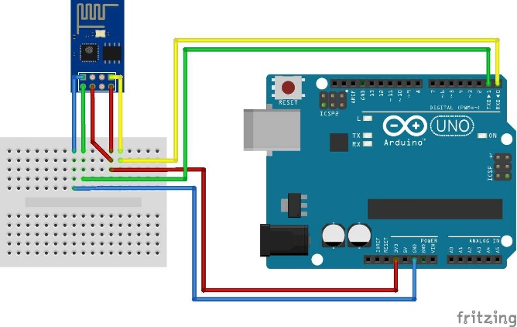RX – – > RX of Arduino

s